Customer churn analysis

- Introduction
Customer churn refers to the situation when customers stop using a company’s product or service. Understanding churn is important for businesses because it helps identify the reasons why customers leave. By analyzing customer data, companies can improve services and develop better customer retention strategies.

- Project Overview
This project analyzes customer churn using a dataset containing customer service and usage information. The objective is to identify patterns in customer behavior and understand the factors influencing churn. Data visualization techniques are used to explore trends and support better business decision-making.

3. Dataset Summary
The dataset used in this project contains customer information related to service usage and churn behavior.
Dataset Details
- Rows: 64374
- Columns: 12
Key Features
- Customer information (CustomerID, Age, Gender)
- Service details (Subscription Type, Contract Length)
- Customer behavior (Usage Frequency, Support Calls)
- Financial information (Total Spend)
- Churn status indicating whether the customer stayed or left

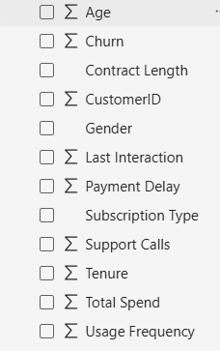

4. Tools and Technologies Used
- Microsoft Power BI – Data visualization and dashboard creation
- Excel – Data preparation and analysis
- Microsoft Word – Project documentation

5. Dashboard Visualization
An interactive Power BI dashboard was created to visualize customer churn patterns. The dashboard includes KPI cards, pie charts, bar charts, and scatter plots to analyze customer behavior and spending patterns.
The dashboard displays key metrics such as:
- Total Customers
- Churn Customers
- Retained Customers
- Total Spend
Various charts were used to analyze churn by subscription type, contract length, and usage frequency.

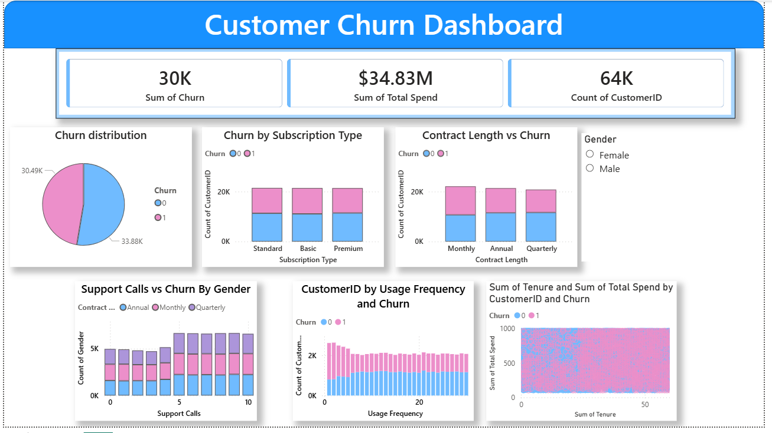

6. Key Insights
- Customers with shorter contract lengths have higher churn rates.
- Customers with higher support calls tend to churn more frequently.
- Customers with longer tenure spend more and are less likely to churn.
- Usage frequency plays an important role in customer retention.

7. Conclusion
Customer churn analysis helps organizations understand customer behavior and identify potential churn risks. By using Power BI visualizations, businesses can gain meaningful insights from data and develop strategies to improve customer satisfaction and retention. The findings of this project highlight the importance of data-driven decision-making in modern business environments.

